General Science
Chapter 5
Adaptation- How Animals Survive

Assignment –Draw a camouflaging animal (Leaf Insect) and Aquatic animal (fish or dolphin) in your fair copy
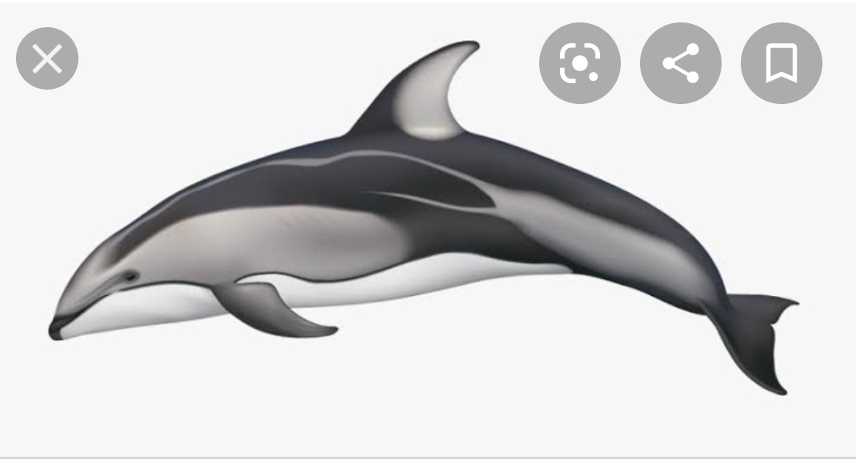
Dolphin
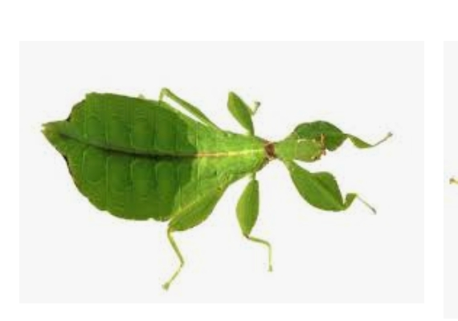
Leaf Insect

